**Exercise 9.**

1. Listen to a project manager describing the process of developing a new car. Number the photos in the right order. Click [***here***](https://drive.google.com/file/d/1Tm9npKMEuRUNc8Zl61IIU3HQ8XvdsYKO/view?usp=sharing)

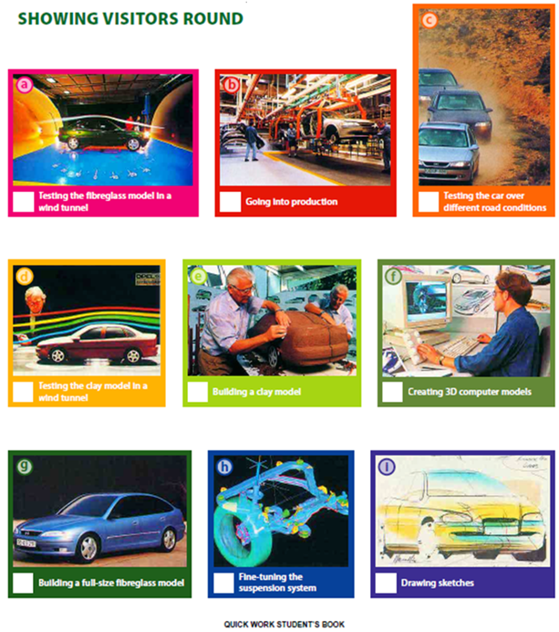

**6 9 8**

**4 3 2**

**5 7 1**

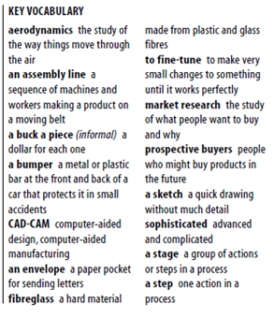2. Listen again and answer these questions:

a. What kinds of calculations are made by the computers?

They create 3d models, and calculate how the car will perform in a crash.

b. Why is clay used to make the first model?

Because it is easy to buid up and take off so the employees can experiment.

c. Who is the fibreglass model shown to?

It is shown to prospective buyers.

d. What else is the fibreglass model used for?

More tests they put it in a wind tunnel. Improve mirrors wheels bumpers, suspension system fine-tuning.

e. Where are the real cars tested and why?

They are tested in a track in Death Valley, California. They are driven in different road conditions to test their performance.

f. How are the cars built?

They are built by robots. The people that work in production only check quality.

3. Listen to the phrases the manager uses to explain the sequence of the actions in the process. Complete these sentences.

a. …It……… ……all…… …starts with……… a basic idea – a few sketches on the back of an envelope.

b. …The……… …next……… ……step…… is to make a clay model of the car.

c. …Then………, ……after…… ……that……, we build a fibreglass model.

d. It’s too late to make major changes to the design ……by…… ……this…… ……stage… .

e. Yes, production’s ……the…… ……final…… ……stage…… .

4. Summarize the stages of the process using the passive voice.

1. Sketches are drawn.
2. 3D computer models are created.
3. A clay model is built.
4. The clay model is tested in a wind tunnel
5. A full-size fiberglass model is built
6. The fiberglass model is tested in a wind tunnel
7. The suspension system is fine-tuned (afinar)
8. The car is tested over different road conditions
9. Car production is started.

**Wind = ‘wind**